Neuronprosthetics Exercise 5

In this exercise, I have modified the model from 1 components to 100 component, to simulate the action potential transmitted on the axon.

I have run 100 ms long simulations (∆t = 25 µs) at 6.3 ◦C with the following settings
- Stimulate the axon at the first compartment with a rectangular 5 ms long pulse with an amplitude of 10 µA. Visualize how the action potential propagates along the axon.
- Stimulate the axon with the same pulse as above but at compartment 20 and 80 simultaneously.
- I have changed the different parameters by myself and fined out the coincidence which will influence the transmittion speed of the action potential on the axon.

The results are as follows:

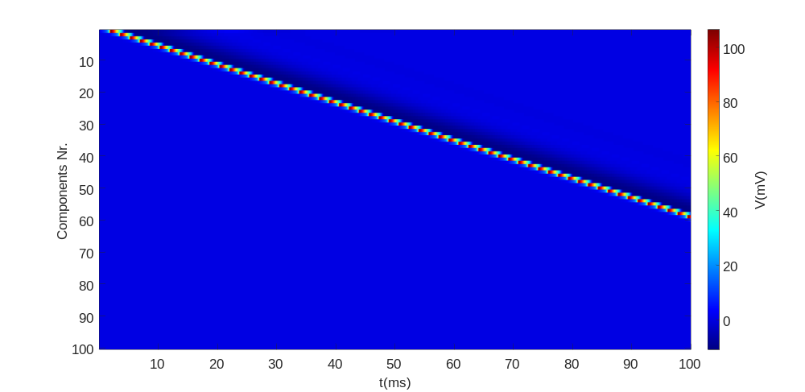

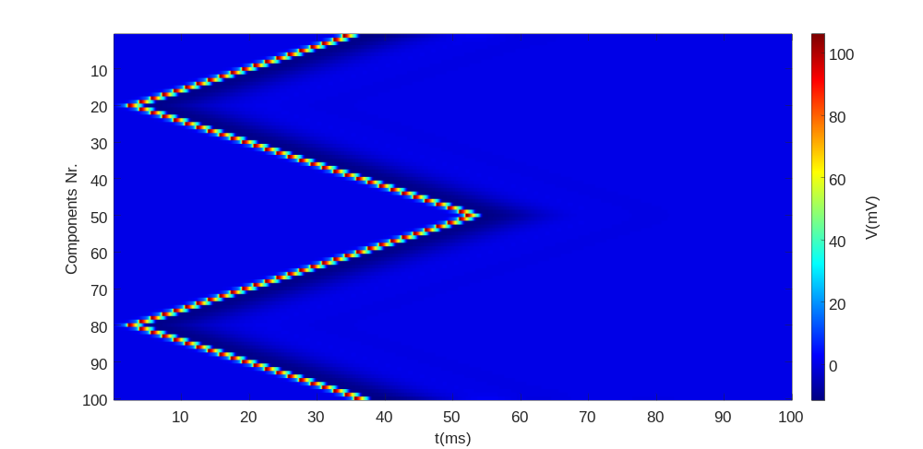

Figure 1: Top: Propagation of the action potential over the different compartments for stimulation at compartment 1. Bottom: Same for simultaneous stimulation at compartments 20 and 80. The colorbar shows the color coding of the potential values.

We can see that in the first picture when man adds a stimulus, the corresponded neuron fires. And the action potential travels along the components and ends finally at the last neuron. For each component, the fire only lasts for a few microseconds and then the neuron get back into the resting state.
From the bottom figure we can see that if we fire two different position of the components simultaneously, the action potential onm eachposition will travel along the two different positions. The action potential ends at the edge of the neuron, and for the other direction, which means the two action potential meets tighter, they disappear simultaneously because of the refraction period.

Interpretion:

1. Stimulate the axon at the first compartment with a rectangular 5 ms long pulse with an amplitude of 10 µA. Visualize how the action potential propagates along the axon. (You may use imagesc in Matlab)

We can see that in the first picture when man adds a stimulus, the corresponded neuron fires. And the action potential travels along the components and ends finally at the last neuron. For each component, the fire only lasts for a few microseconds and then the neuron get back into the resting state.

2. Stimulate the axon with the same pulse as above but at compartment 20 and 80 simultaneously. Explain the resulting propagation profile (why does it stop in the middle?).

The propagation stop at the middle because of the refraction period. For each components when the action potential just passing by is in the refraction period because the gating varianble ‘h’ is still very high, so when two action potential met at the middle, the components at the left and right sides are in refraction period. So the two action potential can propagate neither toward left nor toward right, so it can only disappear at the middle.

3. Explore the different parameters of the model, find out which affect the speed of action potential propagation and explain your findings (Not ion channel parameters. Keep in mind that ρaxon, raxon and lcomp result in a single parameter).

First I tried to triple Ra and the speed of the propagation is slower, you can see that only after 70ms the action potential toward two different directions meet each other.
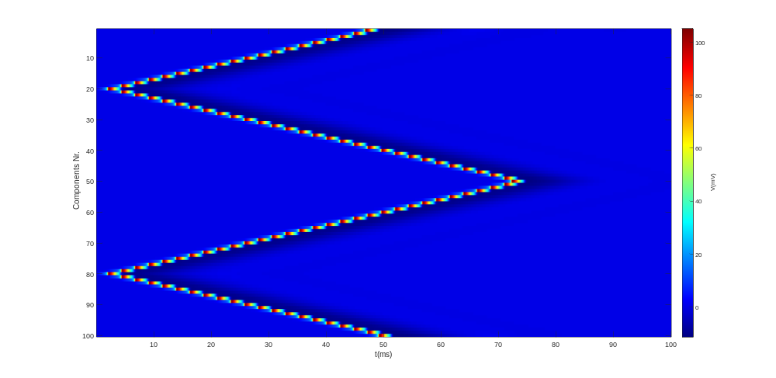

And I tried to increase the C_m to 2e-6 and found that the speed of propagation will also increase, the result is just like follows:

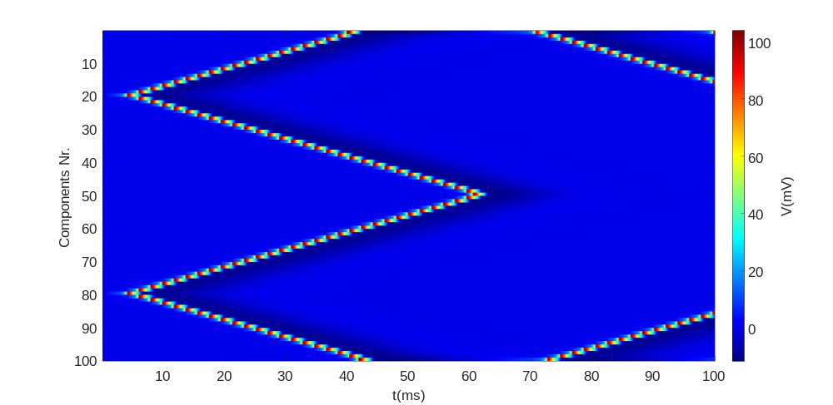

So as a conclusion, the velocity of the propagate is related to Ra,Rm and Cm. the larger is Ra, the smaller is Rm and the larger is Cm, the slower is the propagation speed.
Also from the theoretical course we can find that the velocity is proportional to the $\sqrt{\frac{R_{m}}{R_{a}}}$
Namely:
$$v\sim \sqrt{\frac{R_{m}}{R_{a}}}$$
The larger the Rm is , the better is the electrical isolation, so the faster is the charge process and the propagation velocity is increased. And the Ra influence the length constant, The smaller the Ra is , the larger is the length constant, which means the longer the action potential can propagate along the axon with out reamplification. So the velocity is also increase.
And Cm will effect the time of charge which will then influencr the time constant of the cabel equation,which will also leads to the spend change of the propagation.

Parameter which will influence the speed | If the parameter increase, the propagation speed will…
$$R_{m}$$ | Increase
$$R_{a}$$ | Decrease
$$C_{m}$$ | decrease

